**Project Initialization and Planning Phase**

| Date | 15 August 2024 |
| --- | --- |
| Team ID | LTVIP2024TMID24955 |
| Project Name | SMS Spam Detection - Aiml |
| Maximum Marks | 3 Marks |

**Define Problem Statements (Customer Problem Statement Template):**

As a mobile user, I frequently receive unsolicited and unwanted SMS messages that disrupt my daily activities. These spam messages often contain misleading information, fraudulent offers, or malicious links that put my privacy and security at risk. I need an efficient and reliable solution that can accurately detect and filter out spam messages before they reach my inbox. At the same time, I want to ensure that important or genuine messages, such as appointment reminders or bank notifications, are not mistakenly marked as spam.

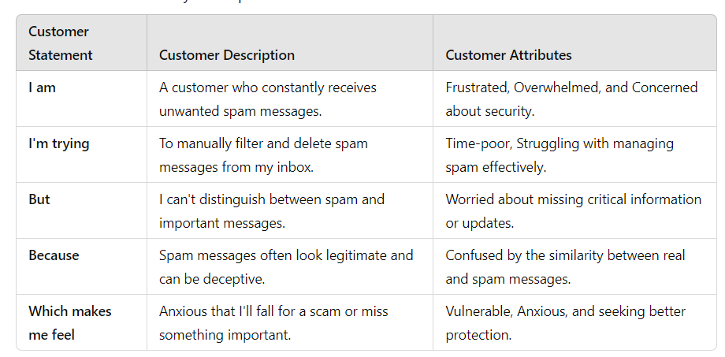

**Example:**

|  |  |  |  |  |  |
| --- | --- | --- | --- | --- | --- |
| **Problem**  **Statement (PS)** | **I am**  **(Customer)** | **I’m trying to** | **But** | **Because** | **Which makes me feel** |
| PS-1 | Receiving unwanted messages | Filtering | I can’t find ham or spam | Often looks likes Legitimate | Anxious, Scared of falling in scam |
| PS-2 | Receives Suspicious links in messages | Detecting | I don’t know  About it | Confused by Ham or Spam | Worried, Seeking peace of mind. |